1st Asian ICMC and CSSJ 50th Anniversary Conference
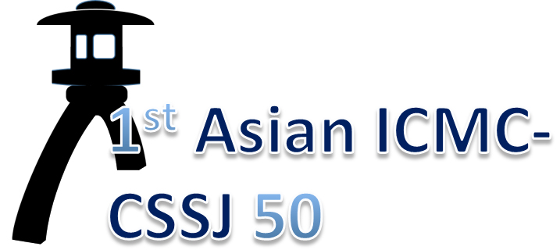
1st Asian ICMC - CSSJ50

Nov. 7-10, 2016, Kanazawa, Japan

Application Form for Sponsorship & Advertisement

Please fill up the Application Form and send it to Secretariat of the 1st Asian ICMC – CSSJ50 by fax or e-mail:
Fax.: +81-3-3818-4573
e-mail: icmccssj50@mlsrv.csj.or.jp

Item No.: ( , , )
1. Conference Bag: 200,000 JPY, 2. Conference Lanyards: 200,000JPY,
3. Promotional Pen: 200,000JPY, 4. Promo. Luggage Tags: 200,000JPY,
5. Promo. Note Book: 200,000JPY, 6. Advertisement on Program Book: 70,000JPY
Total amount: ( ) JPY *Tax included
Payment by Bank transfer
Bank information:
Bank name: SUMITOMO MITSUI BANKING CORPORATION
Branch name: MORIYA BRANCH
Branch address: 4-9, CHUO, MORIYA-SHI, IBARAKI, 302-0115, JAPAN
TEL: +81-297-46-3761 / FAX: +81-297-45-7032
Swift code: SMBC JP JT / Account No.: 936-244988
Account name: ICMC-CSSJ50
Purpose of the remittance: Sponsor charge

Exhibitor Information:
Affiliation:
Contact Person:
Address:
Phone:
Fax:
E-mail:

Thank you very much for your cooperation.

